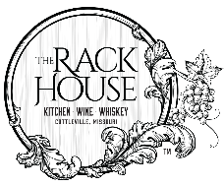
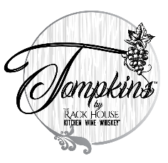

WINE CLUB

To enroll please complete the information below and return to:
The Rack House Kitchen Wine Whiskey ®
5065 State Highway N, Cottleville, MO 63304
Date_________________________
Or
Tompkins by The Rack House®
500 South Main Street, St. Charles, MO 63301

BILLING AND PAYMENT NFORMATION “By signing below, I acknowledge that my credit card will be charged four times a year ($40 and/or $100 each quarter), according to the wine club agreement, for the duration of this membership. I am at least 21 years of age.”

I want to sign up for the:
□ Standard Wine Club - $40/quarter; $70 value / quarter in wine
□ Sommelier Selection - $100/quarter; $150 value / quarter in wine

Member Name _____________________________________________
Date of Birth _______________________Phone_________________________
Email Address ______________________________________________
Billing Address
Street _____________________________________________________
City ____________________________ State _____ Zip ____________
Visa or MasterCard Credit Card
# _______________________________________________
Expiration Date ___________________________ CCV # ___________
Cardholder Signature ________________________________________
WINE CLUB AGREEMENT: By signing up for the The Rack House Kitchen Wine Whiskey® Wine Club(s) you agree to the following: I certify that I am 21 years of age or older. I accept that it is my responsibility to notify The Rack House Kitchen Wine Whiskey® of any changes of address, telephone, email, or credit card information at least two weeks prior to the scheduled payment date. Should a credit card be declined for two consecutive allotments, my membership will be cancelled. The Rack House Kitchen Wine Whiskey® is not responsible for additional shipping charges incurred due to misdirected or returned shipments. If I choose to pick up my shipments at the winery, I will do so at the designated club pick up event or at a mutually agreeable time within 6 weeks of the club release. When picking up quarterly allotments, both bottles must be claimed in the same visit. Only one bottle is permitted to be consumed during the pickup visit. I understand that I may cancel membership by email or in writing at any time after receiving two shipments. I authorize The Rack House Kitchen Wine Whskey® to charge my credit card for payment of the Wine Club shipments.

WINE CLUB MEMBER BENEFITS
- Two bottles of wine quarterly
- For every dollar spent at Tompkins by The Rack House® or The Rack House Kitchen Wine Whiskey® earn points towards a $25 gift card.
  - Receive a $25 Gift Card for every $500 spent
  - Points received on all purchases made at Tompkins and The Rack House
  - Only for members plus one. Points will not be rewarded for parties larger than two, including the member.
  - Points not rewarded for payment of private banquet room events
- During the member’s birthday month, $15 will be given towards any purchase at Tompkins by The Rack House® or The Rack House Kitchen Wine Whiskey®
- A free dessert for each Wine Club Member referred
- Refer four Wine Club Members in a year and receive one free quarter of Club Membership
- Discounts and access to off-menu bottles of wine
- Discounts on Wine Club Dinners and other special events
- Pre-sale access to special events

Standard Wine Club annual cycle is March, June, September, December
(Pickup location: The Rack House Kitchen Wine Whiskey)

Sommelier Selection Wine Club annual cycle is April, July, October, January
(Pickup location: Tompkins by The Rack House)

